- Resolve Merge Conflicts
  - Create a merge conflict intentionally (two users editing the same line).
  - Resolve the conflict and push the changes.
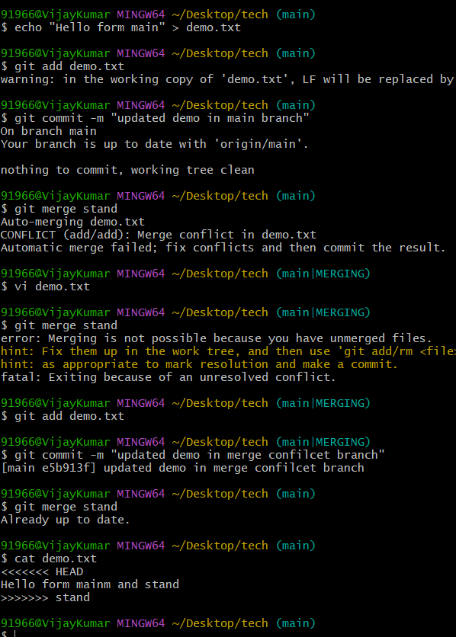

- Recover Deleted Branch
  - Delete a local branch and then recover it using the reflog.
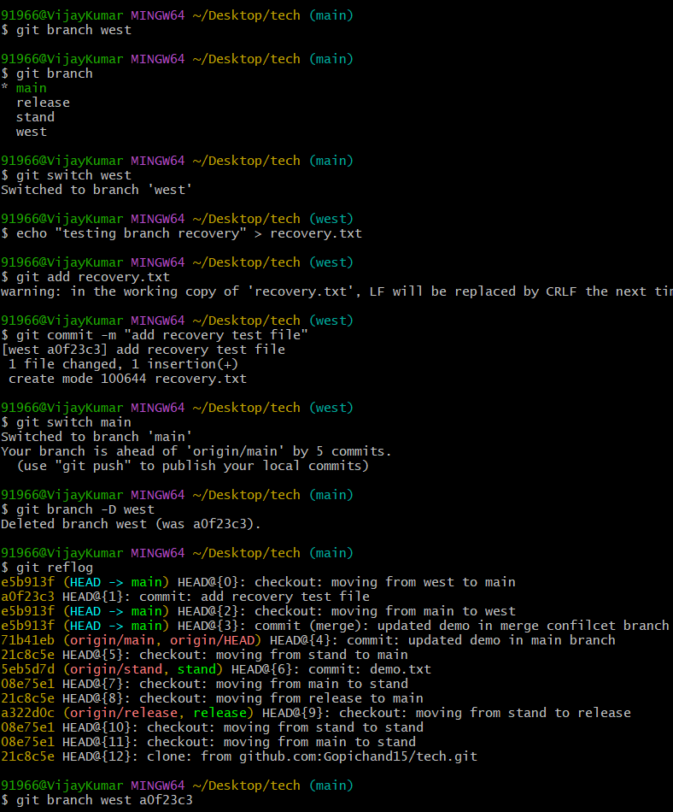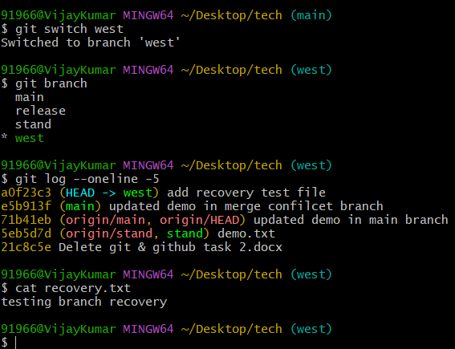
- Undo Wrong Push
  - Push a wrong commit to GitHub, then undo it without losing history.
Step 1:- Make a small wrong change in any file. Then run git add ., then git commit -m "wrong commit", then git push origin main. Now the wrong commit is on GitHub.
Step 2:- Run git log --oneline to see your commits. Copy the short code of the wrong commit.
Step 3:- Run git revert <code>. This makes a new commit that cancels the wrong one. Save the message that opens.
Step 4:- Run git push origin main to send the fix to GitHub.
Step 5:- Run git log --oneline again. You will see both the wrong commit and the revert commit, so no history is lost.
Do not use git reset --hard with git push --force, because that deletes history.

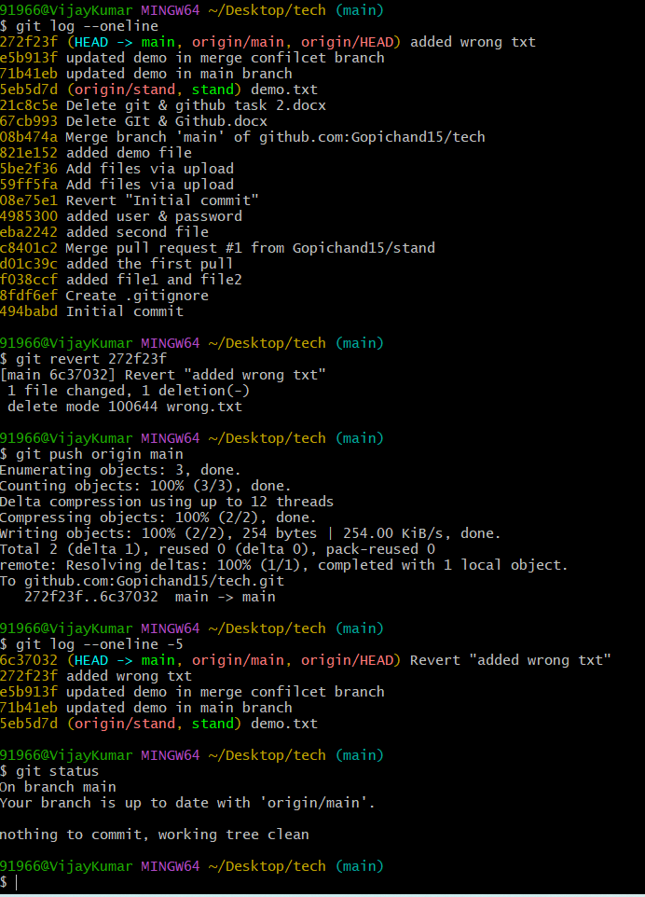
- Amend a Commit
  - Make a commit, then add a missing file to it using git commit --amend.
Step 1:- Make a file and commit it. Run git add file1.txt, then git commit -m "add file1".
Step 2:- Now you remember you forgot one more file. Create it, for example file2.txt.
Step 3:- Add the missing file with git add file2.txt.
Step 4:- Run git commit --amend --no-edit. This puts the new file inside the last commit and keeps the same message. If you want to change the message too, use git commit --amend and edit it.
Step 5:- Run git show --stat to check. You will see both files in the same commit.
Do not amend a commit that is already pushed, because it changes history. If it is not pushed yet, it is safe.

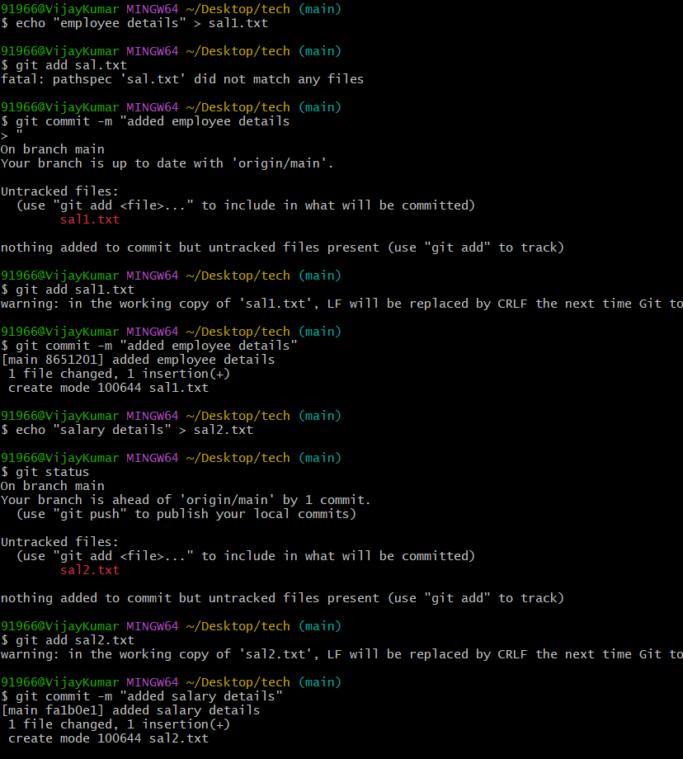
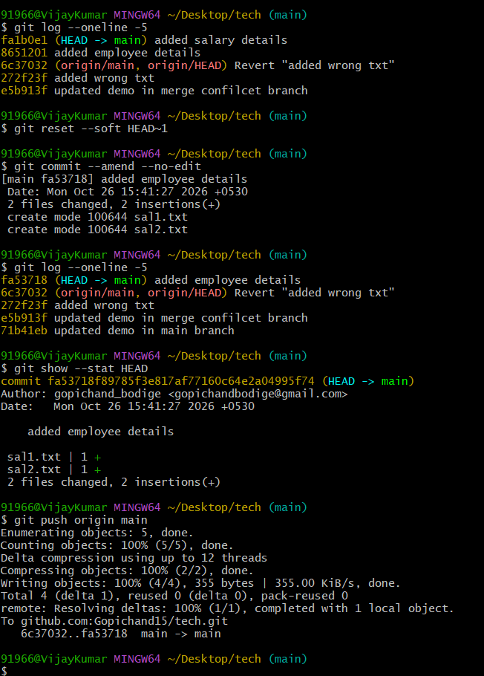

- Cherry-pick a Commit
  - Take a specific commit from one branch and apply it to another branch.
Step 1:- Make a branch and a commit on it. Run git checkout -b feature1, create a file, then run git add . and git commit -m "feature commit".
Step 2:- Run git log --oneline and copy the short code of the commit you want to take.
Step 3:- Go to the branch where you want to put that commit. Run git checkout main.
Step 4:- Run git cherry-pick <code>. This copies that one commit onto main as a new commit.
Step 5:- Run git log --oneline to check. You will see the commit on main with the same message but a new code.
If there is a conflict, fix the file, run git add ., then run git cherry-pick --continue. To cancel, run git cherry-pick --abort.

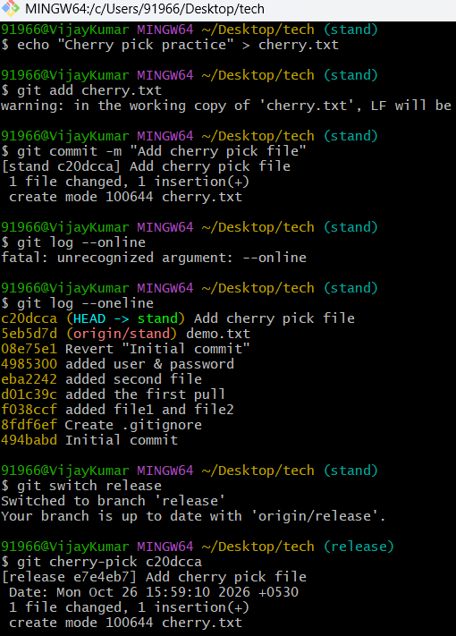
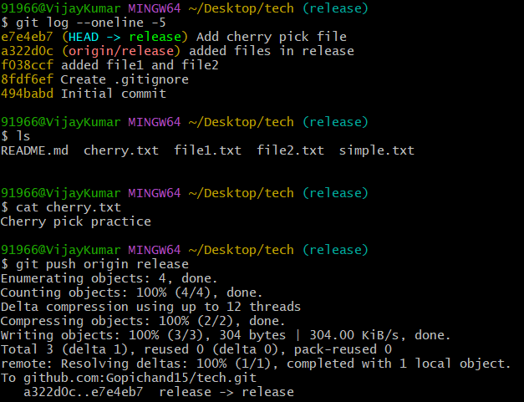
- Interactive Rebase
  - Reorder and squash multiple commits into a single clean commit.
Step 1:- Make 3 small commits on a branch. For example, create a file and run git add . then git commit -m "commit 1", and repeat for “commit 2” and “commit 3”.
Step 2:- Run git log --oneline to see the commits. Decide how many you want to clean up. Here it is 3.
Step 3:- Run git rebase -i HEAD~3. An editor opens with the 3 commits listed, oldest on top.
Step 4:- To reorder, cut a line and paste it in a new place in the list. The top line is applied first.
Step 5:- To squash, keep pick on the first line and change pick to squash (or s) on the other two lines. Save and close the editor.
Step 6:- Another editor opens for the new message. Delete the old messages, write one clean message like “add feature”, then save and close.
Step 7:- Run git log --oneline to check. You will see only one clean commit now.
If something goes wrong, run git rebase --abort to go back. Do not rebase commits that are already pushed, because it changes history.

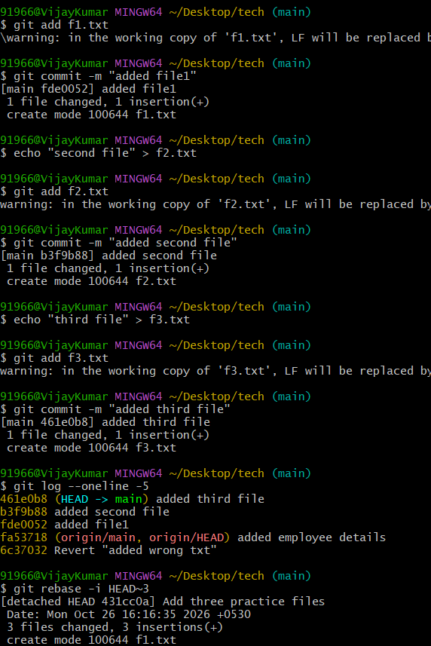
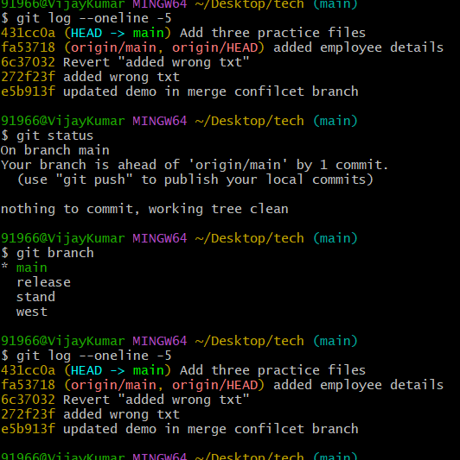
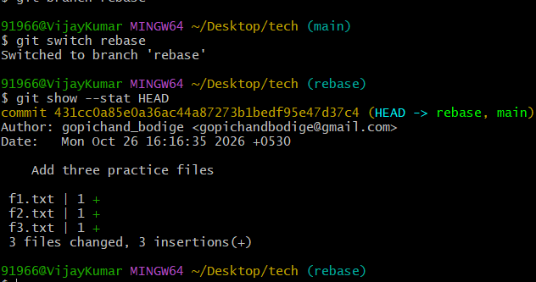

- Tagging & Release
  - Create a version tag (v1.0), push it to GitHub, then delete and restore it.
Step 1:- Make sure your work is committed. Then create the tag with git tag -a v1.0 -m "version 1.0". A simple tag without a message also works: git tag v1.0.
Step 2:- Run git tag to see the tag in the list. Run git show v1.0 to see its details.
Step 3:- Push the tag to GitHub with git push origin v1.0. Now it shows under Releases and Tags on GitHub. You can also click “Create release” there to make a release from this tag.
Step 4:- Delete the tag on your computer with git tag -d v1.0.
Step 5:- Delete the tag on GitHub with git push origin --delete v1.0.
Step 6:- To restore it, first find the commit it pointed to. Run git log --oneline and copy the short code of that commit. Then run git tag -a v1.0 <code> -m "version 1.0". If you deleted the tag by mistake and do not know the code, run git reflog to find it.
Step 7:- Push the restored tag again with git push origin v1.0.
Step 8:- Run git tag and check GitHub to confirm that v1.0 is back.

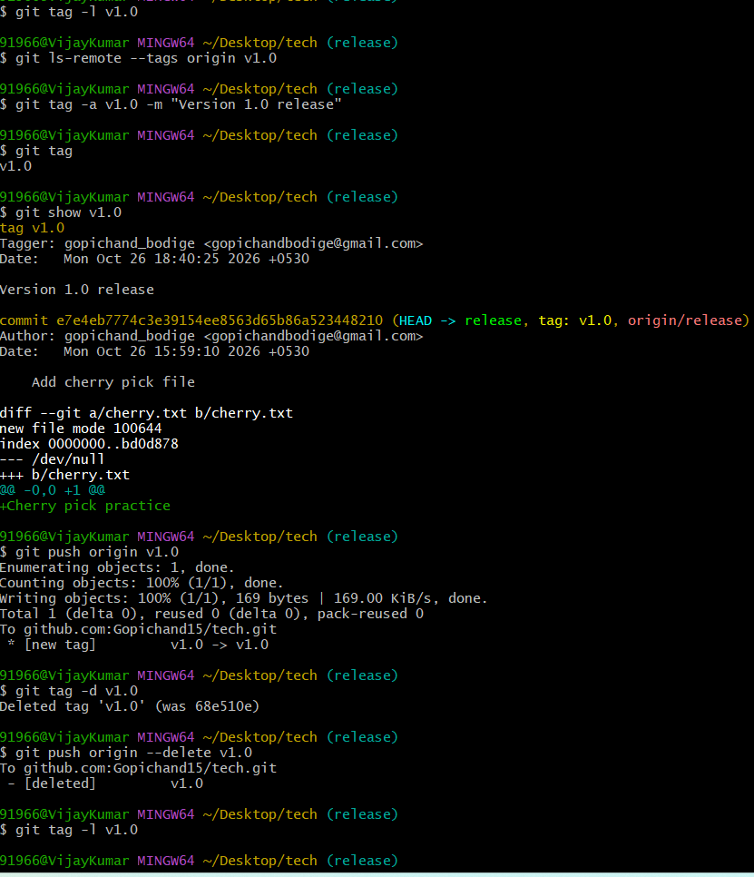
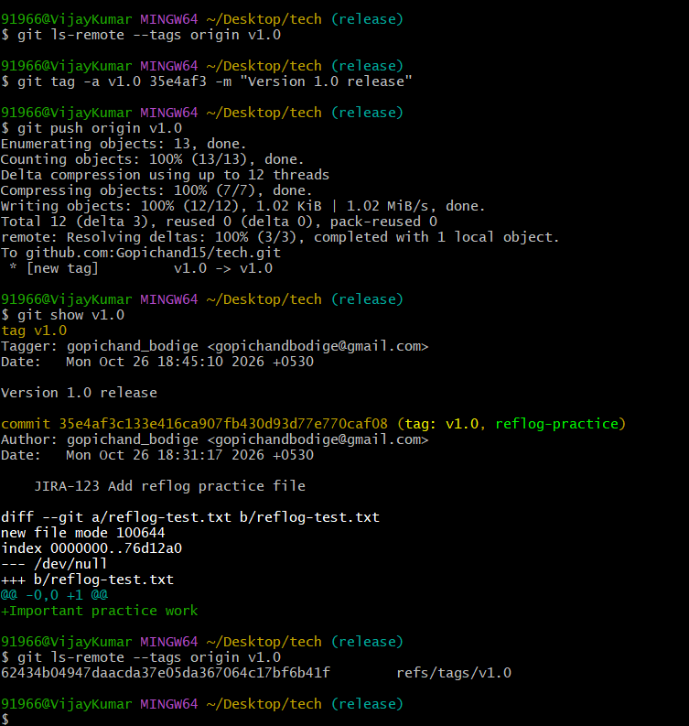
- Clone with Sparse Checkout
  - Clone only a subdirectory of a repo using sparse checkout. Step 1:- Clone the repo without downloading any files yet. Run git clone --filter=blob:none --no-checkout https://github.com/user/repo.git. This gets the history but leaves the folder empty.
  - Step 2:- Go inside the repo with cd repo.
  - Step 3:- Turn on sparse checkout with git sparse-checkout init --cone.
  - Step 4:- Choose the folder you want with git sparse-checkout set folder1. For example, if you only want the docs folder, run git sparse-checkout set docs.
  - Step 5:- Download the files with git checkout main. Use your branch name if it is not main.
  - Step 6:- Run ls to check. You will see only the root files and the folder you chose, and not the other folders.
  - To add one more folder later, run git sparse-checkout add folder2. To get everything back, run git sparse-checkout disable.
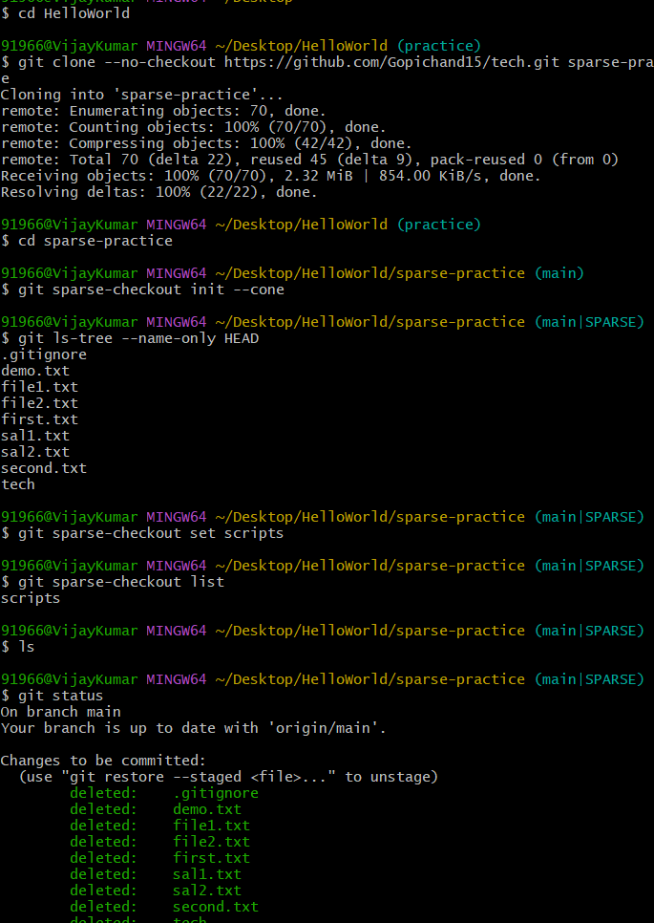
- Reset vs Revert Challenge
  - Demonstrate the difference between git reset --hard and git revert in a repo.
Step 1:- Make a fresh repo to practice. Run git init demo, then cd demo. Create a file and make 3 commits: echo "one" > file.txt, git add ., git commit -m "commit 1". Repeat with “two” and “commit 2”, then “three” and “commit 3”.
Step 2:- Run git log --oneline. You will see 3 commits. Copy the short code of commit 3.
Step 3:- Try revert first. Run git revert <code of commit 3> and save the message. Run git log --oneline again. You will see 4 commits now, because revert adds a new commit that cancels commit 3. The history is safe.
Step 4:- Now try reset. Run git log --oneline and copy the short code of commit 2. Then run git reset --hard <code of commit 2>. This moves the branch back to commit 2 and deletes the later commits and the changes in your files.
Step 5:- Run git log --oneline again. The commit 3 and the revert commit are gone from the history. Only commit 1 and commit 2 are left.
Step 6:- To see the difference clearly, compare both results. Revert keeps all old commits and adds a new one, so it is safe for pushed work. Reset --hard removes commits and changes, so it is risky for pushed work.
Step 7:- If you reset by mistake, run git reflog to find the old commit code, then run git reset --hard <old code> to get it back.
Use git revert when the commit is already pushed and shared. Use git reset --hard only for local work that is not pushed

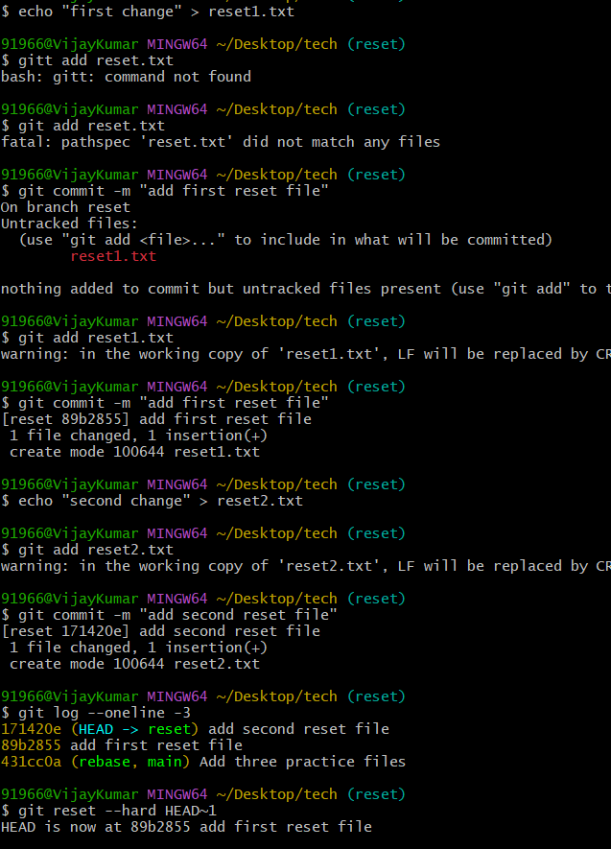\
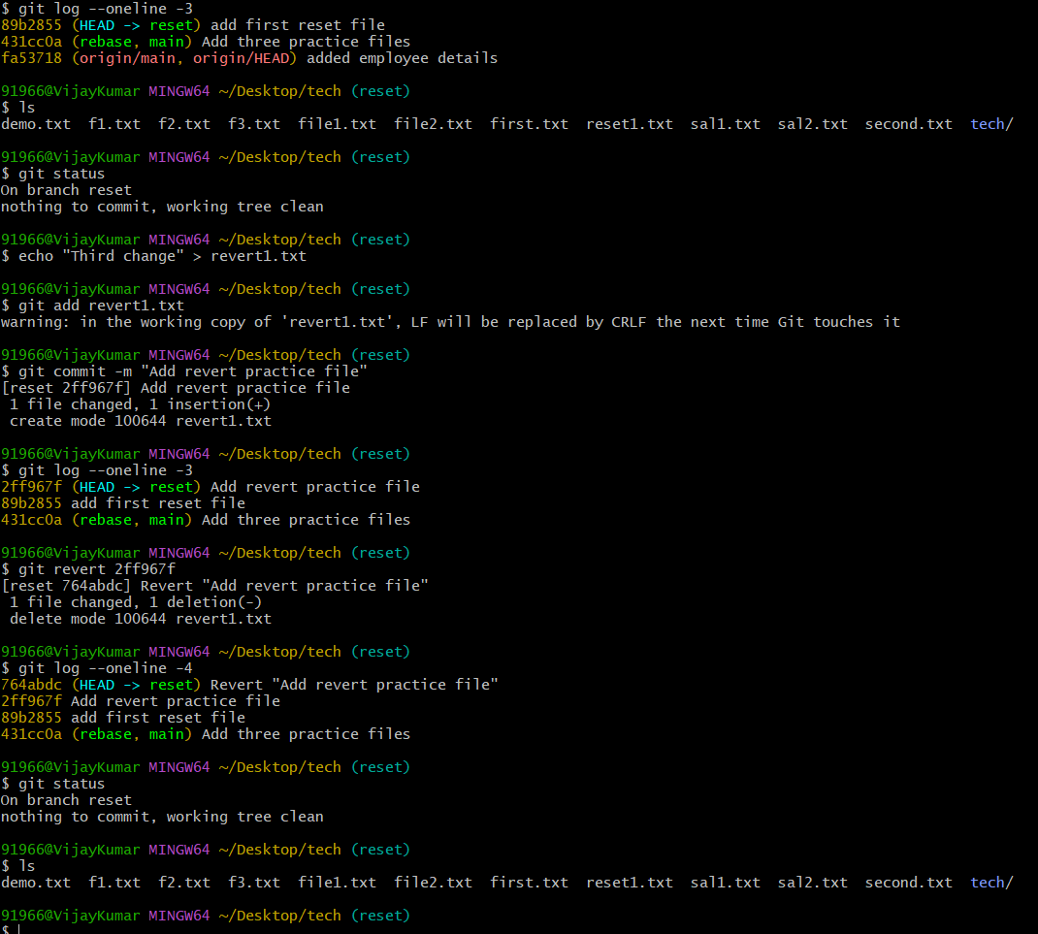
- Detached HEAD Challenge
  - Checkout a specific commit (detached HEAD state) and create a new branch from it.
Step 1:- Run git log --oneline and copy the short code of the commit you want to go back to.
Step 2:- Checkout that commit with git checkout <code>. Git will warn you that you are in “detached HEAD” state. This means HEAD points to a commit and not to a branch.
Step 3:- Run git status to confirm. It will say “HEAD detached at <code>“.
Step 4:- Create a new branch from this commit with git checkout -b new-branch. You can also use git switch -c new-branch. Now HEAD is attached to a branch again.
Step 5:- Run git branch to check. You will see new-branch marked with an asterisk.
Step 6:- Make a change, then run git add . and git commit -m "work on new branch". The commit is now safe on the new branch.
If you make commits in detached HEAD and switch away without creating a branch, those commits can be lost. To get them back, run git reflog, find the commit code, and run git checkout -b rescue <code>. To leave detached HEAD without keeping anything, run git checkout main.

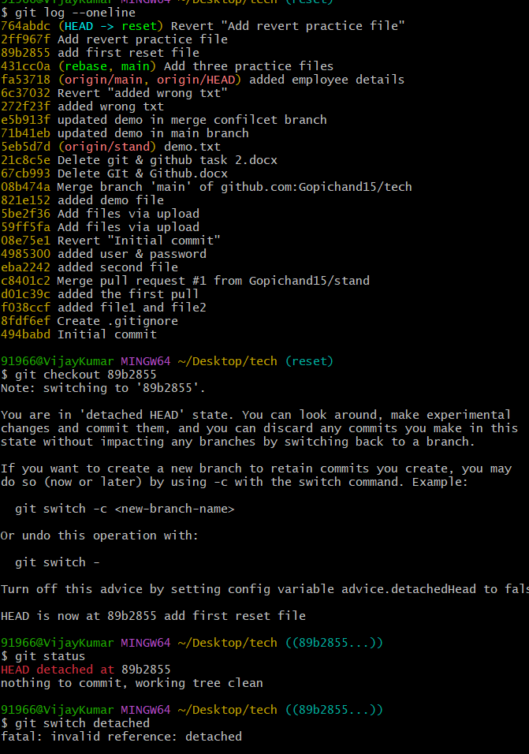
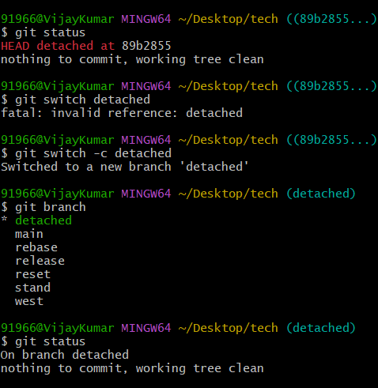
- Git Hooks Challenge
  - Configure a pre-commit hook to reject commits without a message format (e.g., must start with JIRA-XXX)
Step 1:- Go inside your repo and open the hooks folder with cd .git/hooks.
Step 2:- Create a file named commit-msg with no extension. Run nano commit-msg or vi commit-msg.
Step 3:- In the file, write a short shell script. It reads the first line of the commit message and checks that it starts with JIRA- followed by numbers. If it does not match, the script prints an error message saying the message must start with JIRA-XXX and exits with status 1, which stops the commit.
Step 4:- Save and close the file. Then make it executable with chmod +x commit-msg.
Step 5:- Go back to the repo folder with cd ../... Test a bad commit: create a file, run git add . and git commit -m "fix login". The commit will be rejected and you will see the error message.
Step 6:- Test a good commit with git commit -m "JIRA-123 fix login". This will pass and the commit will be created.
Step 7:- Run git log --oneline to confirm that only the correct commit is saved.
The hook is local and is not pushed to GitHub. To share it with a team, keep it in a project folder like .githooks and run git config core.hooksPath .githooks. A person can skip the hook with git commit --no-verify, so teams also add the same check on the server side with CI.
.
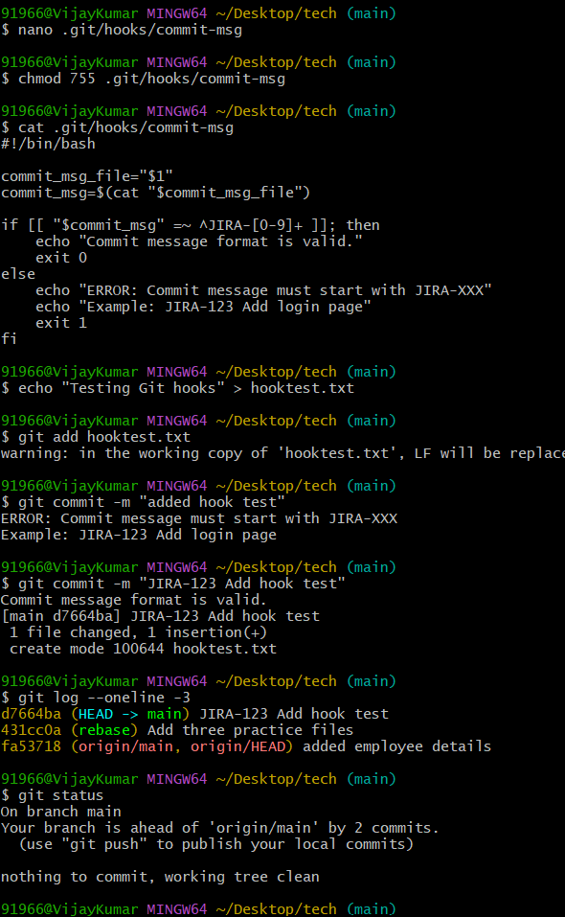
- Squash Merge vs Rebase Merge
  - Show the difference between squash merge and rebase merge with evidence.
Both methods help integrate feature-branch changes, but they produce different Git histories.
Squash merge | Rebase merge
Combines multiple feature commits into one new commit. | Replays feature commits on top of the target branch.
The original feature commits are not preserved individually in the target branch history. | The individual feature commits are preserved, but get new commit hashes when rebased.
Keeps the target history simpler. | Keeps individual changes visible in history.
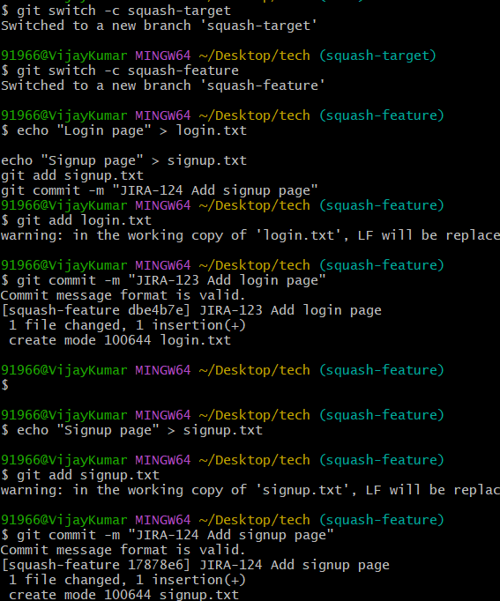
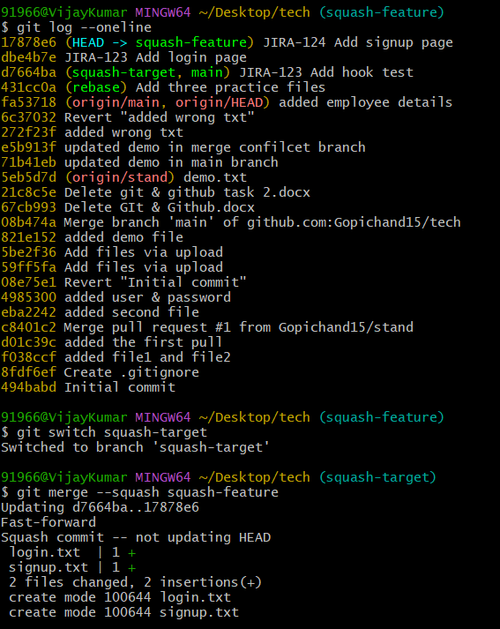
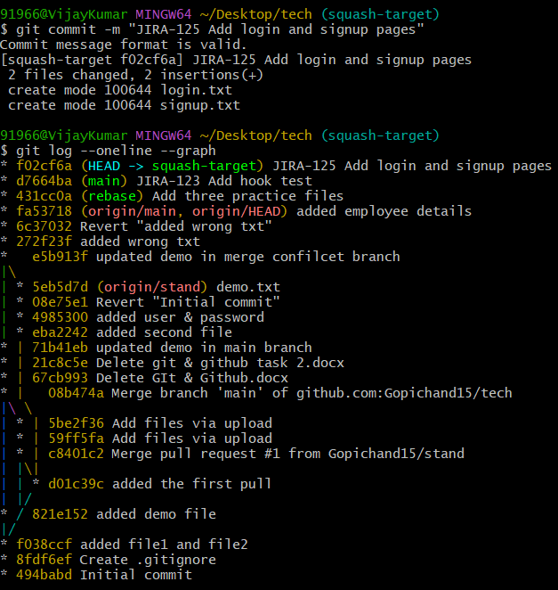
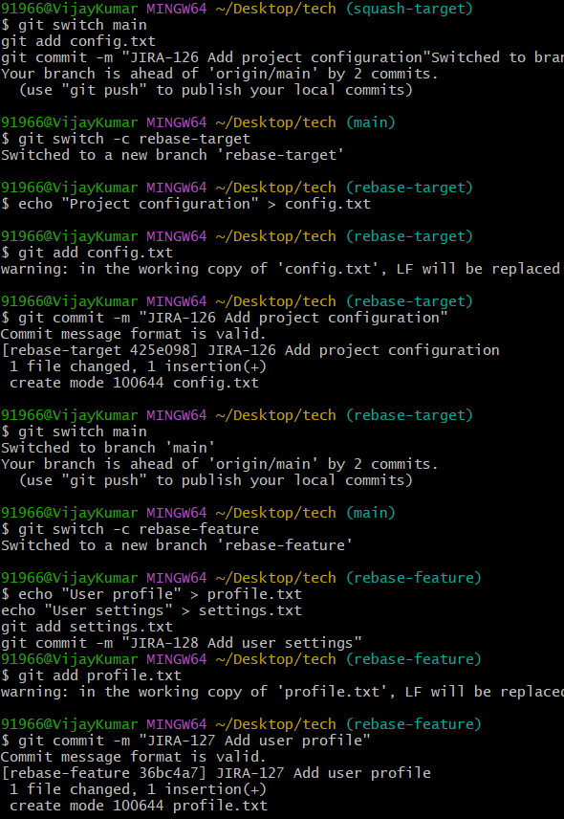
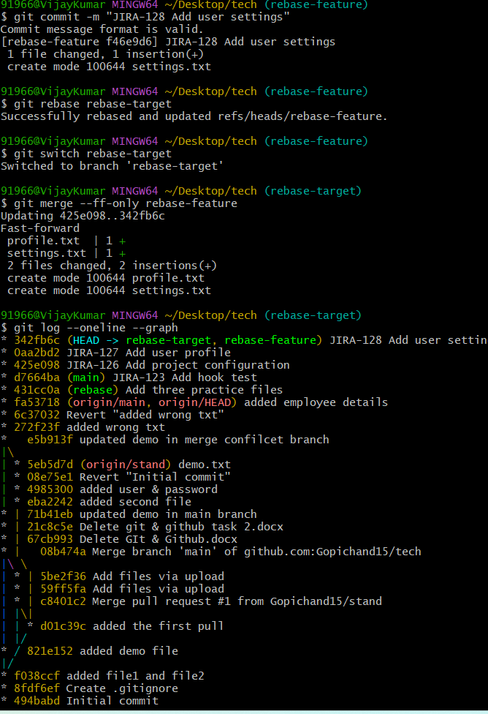
- Fork & Pull Request Workflow
  - Fork a repo, make a change, and submit a pull request to the original repo.
Step 1:- Open the original repo on GitHub and click the “Fork” button. This makes your own copy under your account.
Step 2:- Clone your fork with git clone https://github.com/your-username/repo.git, then go inside with cd repo.
Step 3:- Create a new branch with git checkout -b my-change.
Step 4:- Make your change in a file, then run git add . and git commit -m "my change".
Step 5:- Push the branch to your fork with git push -u origin my-change.
Step 6:- Open your fork on GitHub and click “Compare & pull request”. Check that the base is the original repo’s main and the compare is your branch. Write a short title and description, then click “Create pull request”.
Step 7:- The owner reviews it and merges it. To keep your fork updated, add the original repo with git remote add upstream https://github.com/original-owner/repo.git, then run git pull upstream main.

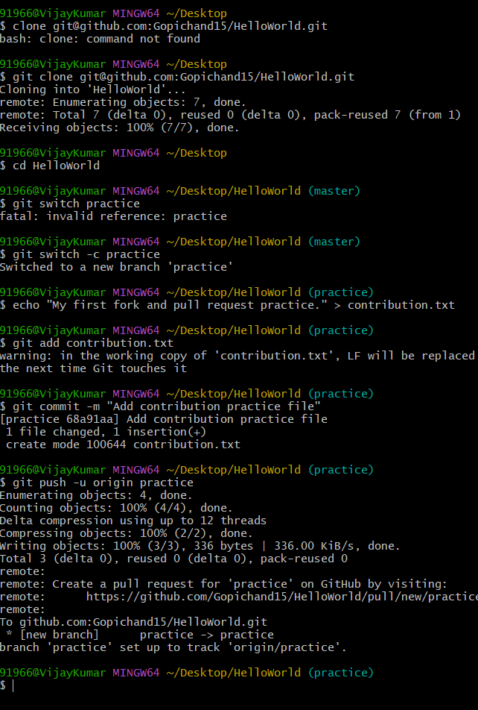
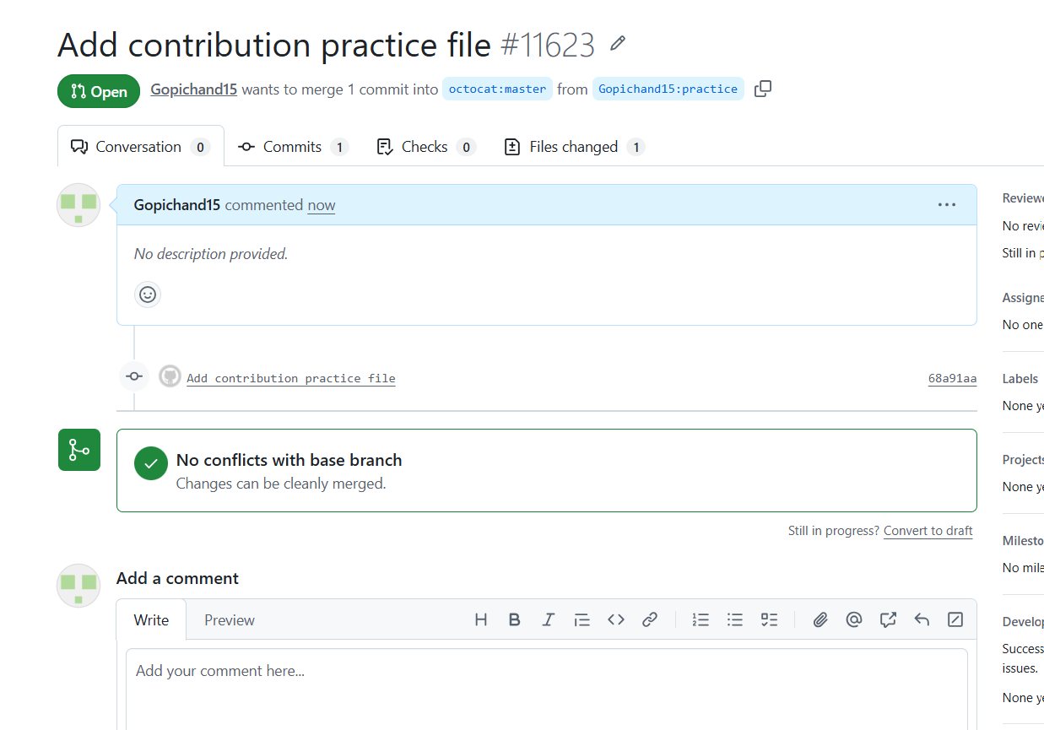
- Recover Lost Commit
  - Commit something, reset hard, and then recover it using git reflog.
Step 1:- Make a file and commit it. Run echo "important" > file.txt, then git add . and git commit -m "important commit".
Step 2:- Run git log --oneline and note the short code of this commit.
Step 3:- Delete it with a hard reset. Run git reset --hard HEAD~1. The commit and the file changes are now gone from the branch.
Step 4:- Run git log --oneline to confirm. The “important commit” is no longer in the list.
Step 5:- Run git reflog. It shows every place HEAD has been, including the lost commit. Find the line with “important commit” and copy its short code.
Step 6:- Bring the commit back with git reset --hard <code>. You can also use git cherry-pick <code> or git checkout -b recovered <code> to keep it on a new branch.
Step 7:- Run git log --oneline and ls to check. The commit and the file are back.

